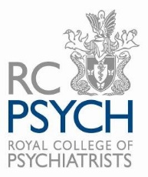

Diversity Monitoring Form

JOB APPLIED FOR | Digital Communications Intern

The Royal College of Psychiatrists is committed to the active promotion of equal opportunities in employment. It is committed to recruiting, retaining, and developing a workforce that reflects the diverse communities we serve.

The College’s core values, Courage Innovation, Respect, Collaboration, Learning and Excellence aims to foster a working environment that respects and values diversity; and ensures equal opportunity for all.

It is therefore important that we monitor and analyse diversity information so that we can ensure that our HR processes are fair, transparent and promote equality of opportunity for all types of staff, whether they are employees or workers.

We appreciate that providing this information is voluntary, however it will always be treated in confidence, and will allow us to run more successful recruitment exercises in the future and ensure that they are fair for all. Please refer to our Human Resources Privacy Notice for further guidance on why we ask for the information we do and your rights.

Any information you provide in this form:
- Will be used by the human resources department for statistical purposes only
- Will not influence the assessment of your application and will not be seen by anybody directly involved in the selection process
- No information will be published which allows any individual to be identified.

We would therefore be very grateful if you could complete and return this diversity monitoring form along with your Application Form, CV, and Cover Letter to by email to HRrecruitment@rcpsych.ac.uk quoting the job title in the subject line.

The College is a proud member of the Disability Confident Employer scheme.

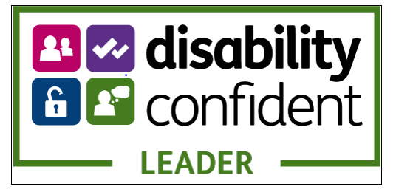

AGE

What is your age? Please mark ‘X’ in one box only

15-19 55 - 59

20-24 60 - 64

25-29 65 - 69

30-34 70 - 74

35-39 75 - 79

40-44 80 - 84

45-49 85 - 89

50-54 90 - 94

NATIONAL IDENTITY

How would you describe your national identity? Please mark ‘X’ in one box only

English

Welsh

Scottish

Northern Irish

British

Other, write in.

Prefer not to say

ETHNIC ORIGIN

A. Asian, Asian British

Bangladeshi ______ Pakistani ______ Indian ______

Indian ______ Any other Asian background, please describe ______

B. Black, African, Caribbean, Black British

African ______ Caribbean ______

Any other Black/African/Caribbean background, please describe ______

C. Mixed, Multiple ethnic groups

White and Black African ______ White and Black Caribbean ______

White and Asian ______

Any other Mixed/Multiple ethnic background, please describe ______

D. White

English/Welsh/Scottish/Norther Irish/British ______ Gypsy or Irish Traveller ______
Roma ______ Irish ______

Any other White background, please describe ______

E. Other ethnic group

Arab ____ Prefer not to say _____

Any other ethnic group, please describe ______

DISABILITY

Please indicate by marking ‘X’ in the appropriate box, mark all that apply.

Chest or breathing problems, asthma, bronchitis

Depression, bad nerves or anxiety

Diabetes

Difficulty in hearing

Difficulty in seeing

Epilepsy

Heart, blood pressure or blood circulation problems

Mental illness or other nervous disorders

Problems or disabilities connected with arms and hands

Problems or disabilities connected with back and neck

Problems or disabilities connected with legs and feet

Progressive illness

Severe disfigurements, skin conditions, allergies

Severe or specific learning difficulties

Autism

Stomach, liver, kidney or digestion problems

Other problems, disabilities.

Prefer not to say

MARRIAGE OR CIVIL PARTNERSHIP

Which of the above best describes your relationship status? Please mark ‘X’ in one box only:

Living in a couple: married or civil partnered

Living in a couple: cohabiting, never married or civil partnered

Living in a couple: cohabiting, previously married or civil partnered

Not living in a couple: never married or civil partnered

Not living in a couple: previously married or civil partnered

Prefer not to say

PREGNANCY AND MATERNITY
Which of the below best describes your pregnancy/maternity status? Please mark ‘X’ in one box only:

Pregnant

Recently given birth

Neither ‘pregnant’ nor ‘recently given birth’

Prefer not to say.

SEX
PREGNANCY AND MATERNITY

What sex are you? Please mark ‘X’ in one box only:

Male

Female

Prefer to self-describe

Prefer not to answer

GENDER

To which gender do you most identify? Please mark ‘X’ in one box only:

Female
Male

Transgender Female

Transgender Male

Non-binary

Prefer to self-describe

Prefer not to answer

SEXUAL ORIENTATION

Which best describes your sexual orientation? Please mark ‘X’ in one box only:

Bisexual

Gay man

Gay woman/lesbian

Heterosexual/straight

Not listed above (If not listed above, please specify)

Prefer not to say.

RELIGION OR BELIEF

What is your religion or belief (including non-belief)? Please mark ‘X’ in the box below as appropriate.

Buddhist

Christian (including Church of England, Catholic, Protestant and

all other Christian denominations)

Hindu

Jewish

Muslim

Sikh

No religion

Not listed above (If not listed above, please specify)

Prefer not to say.

Thank you for completing this form.

The College will process the personal data that you have supplied on this application form in accordance with the terms of the privacy notice for job applicants, which has been made available for you to download from the website as part of this recruitment process. The College will only process your personal data where it has a lawful basis for such processing.

