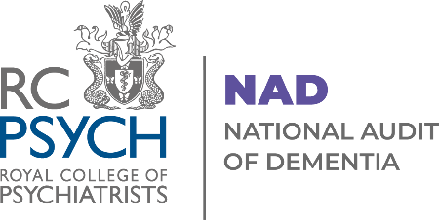

National Audit of Dementia (NAD)
Organogram 2026

Figure 1. Core Project Team

Figure 2. NAD Management Diagram
Decision making input
Advisory input
Implementation Group

Audit Management and Governance

Clinical and Strategic Director (CCQI) | - Directs and has overall responsibility for delivery of all CCQI projects.  - Sits on Steering Group and Implementation Group.
Head of Clinical Audit and Research | - Directs and supervises the work of all audits in the CCQI.  - Sits on Steering Group and Implementation Group.  - Attends contract review meetings.
Project Team  - Programme Manager  - Deputy Programme Manager  - Project Officer x 1 | - Responsible for implementing the project, engagement with participants and day-to-day decision making.  - Meet regularly with Director, Head and Clinical Leads to coordinate tasks, report on progress and, anticipate and report on feasibility.  - Provide regular updates to Implementation and Steering Groups and take forward decisions.
Dementia Clinical Leads | - Provide expert leadership and advice on all aspects of the audit including overall strategy, recruitment and engagement, data utility and analysis, content development, communications and reporting, Quality Improvement.  - Represent and champion the audit.  - Dementia Clinical Lead attends contract review meetings.
Lived Experience Advisors | - Provide expert advice on aspects of the audit including overall strategy, recruitment, engagement, data utility and content development, communications, and reporting.
Implementation Group | - Coordinates expert input into audit development and operation.  - Meets every 6 weeks on average (more frequently in Year 1).
Project Management Data Group | - Works collaboratively on access to and analysis of routine data items incorporated into the dataset  - Strategic view on data accessibility and effects on timeline and deliverables
Steering Group | - Representatives of key stakeholders and partner organisations. Provides advice and guidance on all aspects of the audit including recruitment, engagement, content development, communications, and reporting.  - Meets twice a year.
Lived Experience Reference Group | - Provides advisory support to the audit that reflects issues of importance to patients with dementia and their families/carers (provider Innovations In Dementia).  - Works in parallel to the NAD steering group to provide feedback on all stages of the audit.  - Meets x6 a year.
Reference Panel | - Provide feedback on proposed audit content, impact and utility as locally applied.
Expert Advisors | - Provide statistical and quality improvement advice and guidance to the project team.
Other
CCQI Governance Board | - Chaired by Royal College of Psychiatrists’ President. Membership includes RCPsych CEO, Dean, Clinical Lead for Accreditation. Provides oversight on all CCQI projects in matters of practice, ethics, and methodology. Not involved in decision making related to project content or delivery.

