

NCAP Quality Improvement Collaborative

QI Workbook 2026

Supporting EIP teams to identify challenges, develop change ideas, and test improvements using The Model for Improvement.

Welcome to Your QI Workbook
This workbook helps Early Intervention in Psychosis (EIP) teams identify challenges, develop useful change ideas, and test improvements using The Model for Improvement. You don’t need any previous QI experience - everything is written in clear everyday language with examples to guide you.
If you need support, please email ncapqi@rcpsych.ac.uk

What this workbook helps you do
- Understand your “problem”/ area for Improvement.
- Set a clear aim statement
- Identify who needs to be involved.
- Choose what you are going to measure.
- Develop change ideas.
- Test changes using PDSA cycles.

Top tips for QI success
- Meet regularly as a team- no less than twice monthly.
- Share responsibility.
- Keep tests small and manageable.
- Use real data wherever you can.
- Celebrate progress often.

Trust/Health Board: Click or tap here to enter text.
EIP Team: Click or tap here to enter text.

Area for improvement: Click or tap here to enter text.

Section 1 - Understanding the problem
This section helps your team explore what is happening and why. Using a diagnostic approach helps you identify the real problem and target improvement where it will make the most difference.

  - What do you already know?
(Things you have evidence for)
Click or tap here to enter text.

  - What do you think might be contributing?
(Your first ideas or assumptions)
Click or tap here to enter text.

1.3 Map the current process
(Think about what it looks like and not what it “should” be)
Click or tap here to enter text.

  - What information would help you understand the real issue?
Examples:
- Current performance data (e.g., % offered Family Intervention))
- Staff feedback (e.g., confidence ratings or training needs)
- Service-user insights (e.g. feedback on why they declined the offer)
- Process information (e.g., how and when the offer is made)

Use this table to list the information your team needs, who will collect it, and when.
What information do we need to collect? | Who will collect it? | By when?
Click or tap here to enter text. | Click or tap here to enter text. | Click or tap here to enter text.
Click or tap here to enter text. | Click or tap here to enter text. | Click or tap here to enter text.
Click or tap here to enter text. | Click or tap here to enter text. | Click or tap here to enter text.
Click or tap here to enter text. | Click or tap here to enter text. | Click or tap here to enter text.
Click or tap here to enter text. | Click or tap here to enter text. | Click or tap here to enter text.
Click or tap here to enter text. | Click or tap here to enter text. | Click or tap here to enter text.

Section 2 - Aim Statement

Your aim describes what you want to improve, for whom, by how much, and by when.
It should be SMART:
- Specific – Clearly describes the goal.
- Measurable – You can track progress.
- Achievable – Realistic for your team.
- Relevant – Important to your service.
- Time-bound – Has a clear end date.

Example: “Our aim is to increase the uptake of Family Intervention for eligible families by 10% by May 2026.”
Tips for Writing Your Aim
- Include a numerical value and end date.
- Ensure your aim is clear and specific.
- Confirm everyone has a shared understanding of the aim.
- Be prepared to adapt your aim if you achieve it early.

2.1 Defining your aim
What do you want to improve? | Click or tap here to enter text.
For whom? (population) | Click or tap here to enter text.
By how much? (numerical target) | Click or tap here to enter text.
By when? (timeframe) | Click or tap here to enter text.

2.2 Your aim statement:
Click or tap here to enter text.

 Section 3 - Your QI Team

Think about who needs to be involved to help understand the problem, test change ideas, and support improvement. Consider people who:
- Understand how the process/system you’re trying to improve works
- Will be affected by the changes
- Can help deliver or support the work
- Are keen to try new ideas
- Can help collect data or related admin tasks

List:
People actively involved (day-to-day)
Click or tap here to enter text.

People passively involved (need updates but not daily involvement)
Click or tap here to enter text.

Section 4 - Outcome Measures

Outcome measures can help you see the impact of your change ideas in real time.
Baseline outcome measure: Your starting point- before testing change ideas
Example: Current % of service users who take up or decline Family Intervention

Click or tap here to enter text.

Ongoing outcome measure: how you will track progress over time
Example: % of uptake per week or month

Click or tap here to enter text.

Section 5 - Change Ideas

Change ideas are things you plan to test to help you reach your aim.
Example: Trial a buddy system where experienced staff deliver FI alongside newer staff to improve confidence.

List your change ideas and any linked measures in the table below.
 | Change idea (what you want to achieve) | Associated measure (If needed)
 | Click or tap here to enter text. | Click or tap here to enter text.
 | Click or tap here to enter text. | Click or tap here to enter text.
 | Click or tap here to enter text. | Click or tap here to enter text.
 | Click or tap here to enter text. | Click or tap here to enter text.
 | Click or tap here to enter text. | Click or tap here to enter text.

Section 6 – PDSA cycles

Overview: The PDSA Cycle
PDSA cycles help you test ideas on a small scale so you can see their impact in real time.
Plan - what you will test and what you expect to happen.
Do – carry out the test.
Study - look at what happened and what the data shows.
Act - decide whether to adapt, adopt, or test something new.

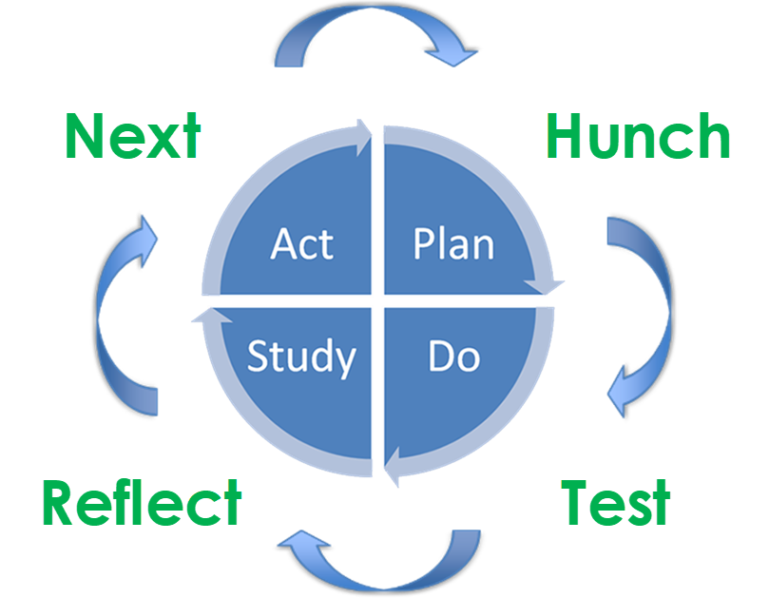

The following tables guide you through each stage of your PDSA cycles.

PDSA Cycle 1:
Who is responsible for this PDSA?
Click or tap here to enter text.

What are you hoping to find out?
Click or tap here to enter text.

PDSA cycle 1
Stage | What to record
Plan | Key questions:  - What will you do?  - Who is involved and how?  - When and where will this happen?  - How will it be done?  - What will you measure?  - Expected outcomes  Notes  Click or tap here to enter text.
Do | Key questions:  - What did you do?  - Unexpected issues?  - Unexpected benefits?  Notes  Click or tap here to enter text.
Study | Key questions:  - What did your data show (before/after)?  - How did this compare to expectations?  - What did you learn?  Notes  Click or tap here to enter text.
Act | Key questions:  - Refine and re-test?  - Embed the change?  - Reject and try something new?  Notes  Click or tap here to enter text.

PDSA Cycle 2

Who is responsible for this PDSA?
Click or tap here to enter text.

What are you hoping to find out?
Click or tap here to enter text.

PDSA cycle 2
Stage | What to record
Plan | Key questions:  - What will you do?  - Who is involved and how?  - When and where will this happen?  - How will it be done?  - What will you measure?  - Expected outcomes  Notes  Click or tap here to enter text.
Do | Key questions:  - What did you do?  - Unexpected issues?  - Unexpected benefits?  Notes  Click or tap here to enter text.
Study | Key questions:  - What did your data show (before/after)?  - How did this compare to expectations?  - What did you learn?  Notes  Click or tap here to enter text.
Act | Key questions:  - Refine and re-test?  - Embed the change?  - Reject and try something new?  Notes  Click or tap here to enter text.

