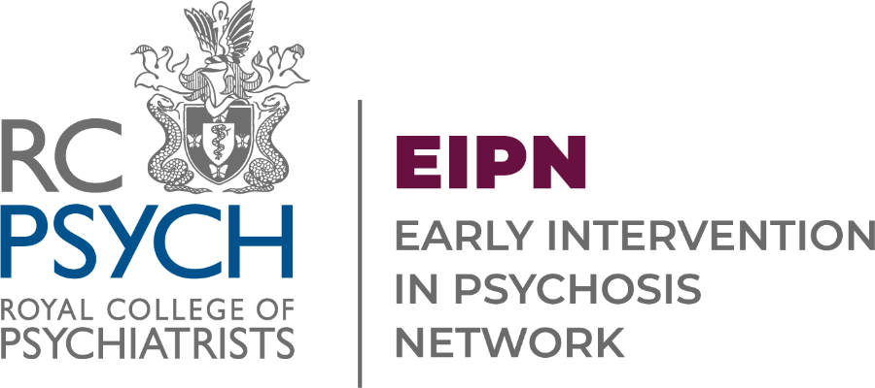



Artwork Submission Form

We are excited to invite EIP teams, their patients and friends and family to showcase their artwork at the Early Intervention in Psychosis Network (EIPN) Annual Forum. This is a wonderful opportunity to share creativity, inspire others, and contribute to the vibrant atmosphere of this year's gathering.
The event
Date: Wednesday 07 October 2026
Time: 10am-4pm
Venue: The RCPsych, 21 Prescot Street, London, E1 8BB
Further details about the event can be found online
What we want
We are looking for artwork created by patients, friends and family or staff. This could be paintings, drawings, photos - anything that shows the wide range of services, adventures and activities offered by EIP teams!
What to do
- Complete this short form.
- Attach in an email or add to this document a photo of the artwork.
- Email this to us at EIPN@rcpsych.ac.uk
- We will then be in contact to confirm if the submission is accepted.
Need to know
- Someone must be in attendance at the forum to bring the artwork for display.
- We will provide Velcro stickers to use on the poster boards provided at the venue.
- Artwork will be displayed on the first floor (where the conference is being held) mezzanine for attendees to view throughout the day.
- We will scan submissions to share following the event.

Your name as the person submitting the art

Your email address

Are you submitting this proposal on behalf of someone?
☐ Yes – please give some details e.g. a patient in the team.

☐ No
Title of the Artwork:

How should we display the artists’ name? (If this is for a team, then the team name)
______________________________________________

Please confirm if we have permission for the network to use the artwork in its future publications (such as on the cover of local and national reports):
☐ Yes
☐ No
Please confirm if we have permission for the network to resize, crop, or edit the artwork to fit in appropriate publications:
☐ Yes
☐ No

