The impact of COVID-19 on the mental health of healthcare workers: Results of a Survey

Julia Bugelli

Abstract

Summary: This is a report of a short survey analysing the impact COVID-19 had on the mental health of healthcare workers, conducted in the United Kingdom during the second wave of the pandemic. The survey examined how healthcare workers (HCWs) rated their own mental health versus that of their peers as well as the symptoms they struggled with mostly and any contributory factors. It highlights differences between gender, professional groups, and COVID-19 related circumstances.

Keywords: mental health, healthcare workers, COVID-19

Background

I am a year 12 pupil from North Wales, and as an aspiring medic with an interest in human psychology preparing for my AS levels, I was interested in the mental health impact of this pandemic on healthcare workers.

Method

This survey consisted of a brief questionnaire with 10 questions, see Table 1. It was shared through the social media sites Facebook and Twitter, as well as some HCWs’ WhatsApp group chats/networks. It was forwarded, retweeted, and reposted by some to reach a wide audience. The survey was open between October 24th and November 1st, 2020, with the majority of the data collected in the first 3 days.

Table 1
Questions |  | Answer Choices
1 | What is your gender? | Multiple Choice
2 | What is your role in the health service? (Check all that apply) | Checkboxes
3 | On a scale of 1-10 how much do you think COVID-19 has affected YOUR mental health? | Slider scale (-10 to 10)
4 | On a scale of 1-10 how much do you think COVID-19 has affected OTHER health care workers’ mental health? | Slider scale (-10 to 10)
5 | Which of the following have you experienced personally during the pandemic? (Check all that apply) | Checkboxes
6 | If you experienced any of the above, what do you think contributed to this? (Check all that apply) | Checkboxes
7 | Do you feel any aspect of your work environment impacts your mental wellbeing (positively and/or negatively)? | Multiple Choice and Comment Box
8 | Does/did your work involve direct contact with COVID-19 positive patients? | Multiple Choice
9 | Did you have to self-isolate at any point during the pandemic? | Multiple Choice
10 | Have you tested positive for COVId-19? | Multiple Choice

Results

627 HCWs took part, 71.47% (446) of which were female, 28.04% (175) were male, 0.32% (2) were other, 0.16% (1) preferred not to say, and 3 skipped the question. (see Fig.1)
The study was aimed at all HCWs and the respondents included a wide range of roles. 46.17% (289) were doctors, 30.51% (191) nurses, 4.95% (31) allied health professionals, 4.15% (26) midwives, 2.56% (16) management, 1.76% (11) wider healthcare team, 1.44% (9) psychology, 1.12% (7) dental team, 0.96% (6) pharmacy, 0.80% (5) ambulance service, 0.64% (4) health informatics, 0.64% (4) healthcare science, 0.64% (4) public health, 0.32% (2) medical associate professions and 7.03% (44) other. The ‘other’ option included 12 administration or clerical staff, 6 healthcare support workers, 2 physician associates, and one of each: academic, occupational therapist, enhanced support care specialist, dispenser (pharmacy assistant), worker in a GP practice, oral surgeon, optometrist, resuscitation officer, advanced nurse practitioner, play specialist, health visitor, radiographer, physiotherapist, major trauma network worker, non-executive director, medical student, third sector worker, dietician, paramedic-in a GP surgery, podiatrist, CAMHS, housekeeper, carer, facilities supervisor. (see Fig.2)
Most comparisons were drawn between females (446) and males (175), doctors (289) and nurses (191), female doctors (131) and female nurses (182), female doctors (131) and male doctors (154) as there are sufficient numbers to make the data more reliable. Comparisons were also made between the results of those whose work involved direct contact with COVID patients (450) and those whose work did not (175), those who had to self-isolate at any point during the pandemic (271) with those who did not (355), and those who tested positive for COVID-19 (79) with those who did not (548).
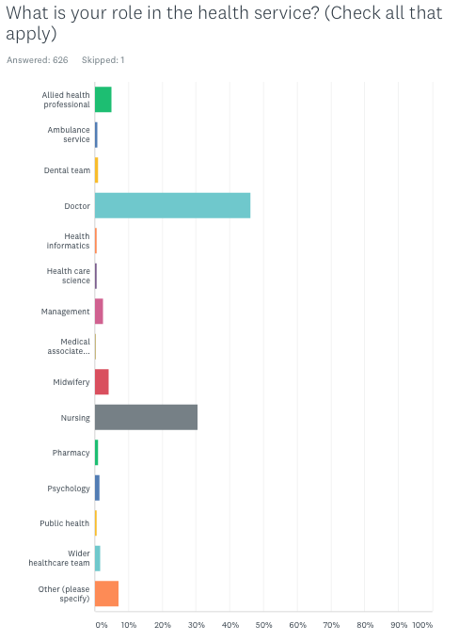
Most of the respondents are based in the UK, but a small number of answers from overseas cannot be ruled out. However, it is highly unlikely that these answers will have significantly skewed the data, meaning most conclusions can be drawn relating to the UK while also providing some wider variety.
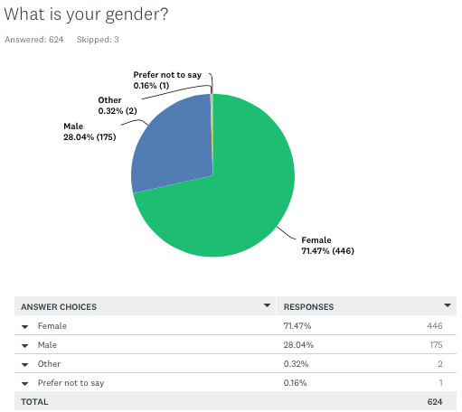
Fig.1

Fig.2
The first two questions aimed to assess the impact of COVID-19 on the respondent’s mental health and the perceived impact on their peers, see Table 2.

Table 2- Table showing the impact on mental health of healthcare workers and peers
 | 1. On a scale of 1-10 (with -10 being very negative and 10 very positive) how much do you think COVID-19 has affected YOUR mental health? | 2. On a scale of 1-10 how much do you think COVID-19 has affected OTHER healthcare workers’ mental health?
Average | -3.07 | -4.40
Females | -3.39 | -4.55
Males | -2.29 | -3.99
Nurses | -3.28 | -4.30
Doctors | -2.98 | -4.68
All other roles, (excluding doctors and nurses) | -2.90 | -4.04
Female Nurses | -3.44 | -4.40
Male Nurses* | -0.11 | -2.22
Female Doctors | -3.55 | -5.18
Male Doctors | -2.49 | -4.24
Worked directly with COVID patients | -3.10 | -4.55
Did not work directly with COVID patients | -3.00 | -4.00
Had to self-isolate | -3.15 | -4.40
Did not have to self-isolate | -3.00 | -4.39
Tested positive for COVID | -2.87 | -3.86
Did not test positive for COVID | -3.10 | -4.48
*Male nurses were a small group

The next two questions are linked and refer to the types of mental health difficulties that HCWs have faced, and the possible reasons for these.
In total, 95.22% of HCWs’ suffered some level of mental health difficulties during the first few months of the pandemic. ‘Anxiety’ topped the list at 68.90%, followed by ‘exhaustion - 57.58%, insomnia/poor sleep - 55.50%, fear - 48.64%, depressive feelings/low mood - 44.82%, burnout - 39.55%, loneliness - 30.46%, psychological distress - 29.19%, general health concerns - 25.52%, severe stress - 21.85%, worsening obsessionality - 10.05%, stigmatisation feelings - 8.13%, PTSD features - 7.18%, somatisation - 4.15%, other - 6.22% and none of the above - 4.78%’. The ‘other’ option included worry or concern, guilt, fatigue or tiredness, frustration, grief, and a couple who mentioned they felt it was an overreaction. Some also mentioned ‘boredom’, ‘helplessness’, ‘anger’, ‘moral trauma’, ‘paranoia’, ‘isolation’, ‘alienation from usual support services’, ‘recurring nightmares about loved ones’ and even ‘suicidal ideation’. There was one positive comment that ‘remote and flexible working has massively improved [their] overall job satisfaction. This is a silver lining’. (see Fig.3)
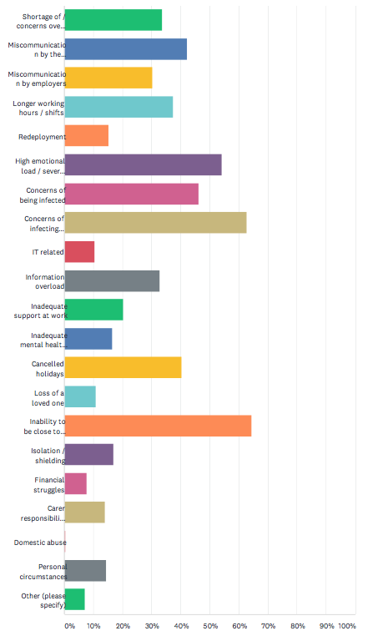
Question 4 aimed to find possible explanations for why so many had suffered from these mental health problems. This was answered with ‘inability to be close to family and friends - 64.41%, concerns of infecting friends or relatives - 62.80%, high emotional load / severe stress - 54.11%, concerns of being infected - 46.22%, miscommunication by government - 42.35%, cancelled holidays - 40.42%, longer working hours / shifts - 37.52%, shortage of / concerns over PPE - 33.66%, information overload - 32.85%, miscommunication by employers - 30.27%, inadequate support at work - 20.29%, isolation / shielding - 16.91%, inadequate mental health support - 16.43%, redeployment - 15.30%, personal circumstances - 14.49%, carer responsibilities - 14.01%, loss of loved one - 10.79%, IT related - 10.47%, financial struggles - 7.73%, domestic abuse - 0.48%, other - 7.09%’. (see Fig.4)
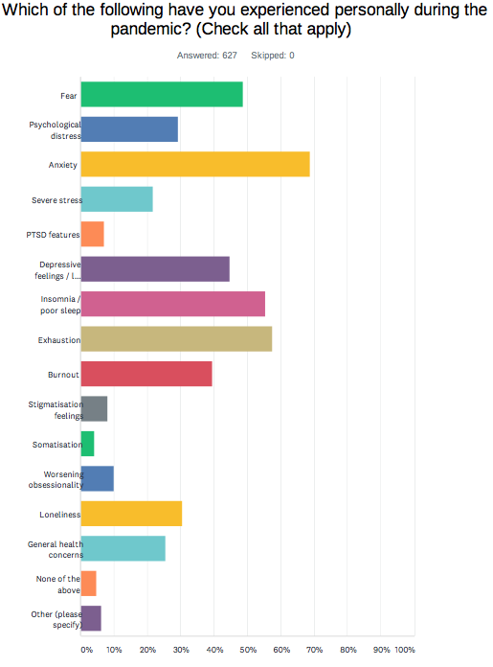
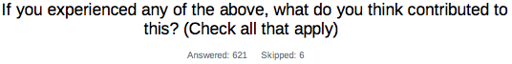
Fig.3
Fig.4

To help find possible solutions and to discover more about what factors in the workplace contributed, this next question was asked; “Do you feel any aspect of your work environment impacts your mental wellbeing (positively and/or negatively)?”. This was answered with ‘yes, positively - 8.95%, yes, negatively - 20.13%, yes, both positively and negatively - 60.22%, no - 10.70%’, and 190 comments explaining why (positive and negative). (see Fig.5)
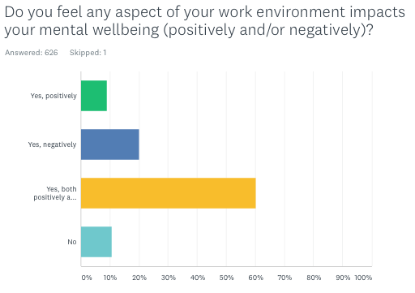
Fig.5

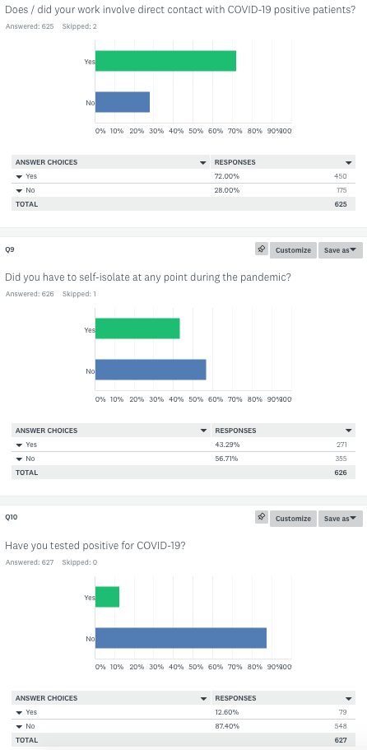
From my data, 43.29% of HCWs had to self-isolate but only 12.60% have tested positive for COVID-19, although the second figure could have been much higher if mass testing was available sooner. As expected, this figure was slightly higher (15.78%) in those that worked in direct contact with the virus, and in males (as more males worked in direct contact than females). Although these figures may seem small, it was estimated that up to 6% of the population of England had had the virus, although official testing statistics showed around 1.7% (at the time the survey occurred), which demonstrates the risk the HCWs have been taking by going to work and dealing with COVID-19 daily. (see Fig. 6)
Fig.6
Discussion

The first question was "On a scale of 1-10 how much do you think COVID-19 has affected your mental health?", and was answered, on average, with -3.07 (with -10 being very negative and 10 very positive). This figure was slightly lower in females, -3.39 and slightly higher in males, -2.29, which corresponds with other sources, stating that females' mental health has been disproportionately affected compared to males. This could be due to biological factors meaning that females tend to suffer from more mental health difficulties than males, combined with social factors such as toxic masculinity and stigma in society facing men suffering from mental health problems. While comparing the responses of people with different roles within the hospital, nurses had slightly lower mental health levels than others, replying on average -3.28, doctors were ever slightly above the average with -2.98 and other professionals combined were also above the average at -2.90. This data implies therefore that females and nurses’ mental health was more negatively impacted by COVID-19. However, the vast majority of nurses in my survey were female (95.29%- 182 out of 191), and the majority of doctors participating were male (53.66%- 154 out of 287). Therefore, on comparing the responses of female doctors and female nurses, it was found that female doctors had responded with -3.55 on average, compared to -3.44 for female nurses. The number for male doctors was -2.49, higher than female doctors, which affected the average difference between nurses and doctors. For male nurses the figure was -0.11, however, closer inspection of the individual responses to the other questions suggests that 2 out of the 9 male nurse respondents may have misunderstood the slider scale and replied with positive numbers when they meant negative, therefore skewing the results. In conclusion, it seems that hospital roles did not greatly impact the suffering of mental health difficulties, but gender was more of a differentiating factor.
As seen in Table 2, there were slight differences between those whose work involved direct contact with COVID patients, compared to those whose work did not and those who had to self-isolate, compared to those who did not, however, these differences are too slight to draw any definitive conclusions. Unexpectedly perhaps, those who tested positive, on average rated the effect of COVID-19 on their mental health as -2.87, compared to -3.10 for those who did not test positive. It would be interesting to know why, and one wonders if maybe they were more preoccupied with their physical health to focus on their mental health; they had less anticipatory fear of the virus; or some might have believed that they had acquired a degree of immunity.

When the same question was asked about the mental health of other HCWs instead of their own, interestingly, the figures were around 1 lower in all categories, with an average of -4.40. This was especially noticeable in doctors and in males who thought COVID-19 had affected other HCWs' mental health by 1.70 more negatively than their own (doctors, -4.68 compared to -2.98) (males, -3.99 compared to -2.29). There was a slightly bigger difference between those whose work involved direct contact, -4.55, and those whose did not, -4.00, although there was no notable difference between those who had to self-isolate and vice versa. It is also of interest that those who tested positive answered on average that others' mental health had been impacted by -3.86, compared to those who did not test positive, -4.48. This narrower gap could be a coincidence, however, it could also be that those who have not tested positive may feel that they have not been as badly affected as those who have had the virus. All of this suggests that they are HCWs who possibly saw colleagues or others in the news/media struggling and assumed others’ problems were worse than their own, showing the caring and empathetic nature of HCWs.

When one considers how HCWs responded to the contributory factors for their mental health symptoms, it is no surprise that ‘anxiety, exhaustion, and insomnia/poor sleep’ topped the list. The pandemic increased anxiety provoking factors and reduced usual alleviating opportunities that help maintain a normal work-life balance. For example, inability to be close to family and friends, miscommunication, and concerns over PPE (Personal Protective Equipment), being infected and infecting others contributed to the increased anxiety and fear; changes in shift patterns may have altered established sleep patterns, leading to poorer sleep and a build-up of exhaustion. The lack of respite is also evident as many felt ‘cancelled holidays’ had affected their mental health, which is unsurprising considering the longer and more intense working days. The Thursday night clap for 10 weeks in early lockdown, was a much appreciated gesture by the public, lifting the spirits of many. However, many HCWs also felt the pressure of being portrayed as heroes. It’s worth noting that ‘burnout’ was experienced by almost 40% of HCWs in this survey. This is especially worrying, as it affects performance and staff sickness. This was 7 months after the first lockdown and several months later, we are still experiencing the debilitating effects of the pandemic, with the NHS (National Health Service) having faced winter pressures while also trying to keep up some elective work. Such levels of staff burnout could lead to increased pressure on the remaining staff, in turn leading to worsening mental health levels in a vicious cycle, which could ultimately cause the NHS serious staff shortages.

Other suggestions for contributory factors included lockdown and the disruptions it caused, staffing shortages as many colleagues were isolating, or lack of services that usually work in partnership with the NHS as many of these moved online making it harder to deliver good quality of care (such as ‘speech and language therapy to young children’). The public behaviour was also picked up on due to the ‘weight of expectations thanks to the Thursday night clap’, ‘misconceptions around the NHS being closed’, and sadly, the ‘hostility’ some felt from the public and people ignoring the rules. In addition, child-related issues including childcare, homeschooling, and fears that children were missing out. People who had had COVID, passed it on or had on-going symptoms, and the changes in recent months all negatively affected their mental health. Sadly, there was mention of perceived discrimination, both racial and against the shielding and/or disabled. Financial or employment worries, workplace behaviour, lack of training opportunities, missing family, inability to attend funerals, inability to plan for the future, uncertainty of the impact, responsibility as a clinical leader, ‘the constant grind, no end in sight’ were all also contributing factors, and of concern, one respondent also mentioned that ‘colleagues have been instructed to lie about COVID deaths’. The question was skipped by 6, and 4 answered none, suggesting that only 10 of the 627 respondents' mental health was completely unaffected, compared to 30 from the previous question, who probably saw impacts on others even if they weren’t particularly affected personally.

In line with previous questions, many more women answered that they had experienced all symptoms other than ‘stigmatisation feelings’ and ‘worsening obsessionality’ worse than males, especially ‘anxiety’ and ‘insomnia/poor sleep’. Again, when comparing the results between roles, it seems that nurses suffered from many more of all of these mental health difficulties other than ‘worsening obsessionality’ and ‘somatisation’, however, this seems due to the gender imbalance in the number of nurses and doctors who participated. When comparing the results of female doctors with female nurses, the results were very similar in the most part, with ‘loneliness’ dramatically higher in female doctors (39.69% compared to 26.37%) and ‘general health concerns’ almost double in female nurses (31.32% compared to 16.79%). Sadly, all 131 female doctors and 96.70% of female nurses said that they had experienced mental health difficulties, which is higher than the average. All roles other than doctors and nurses comprised 88.20% females, which explains the very similar results to the female doctors and nurses. The main difference was the slightly lower levels of ‘exhaustion, insomnia/poor sleep and burnout’ and slightly higher levels of ‘worsening obsessionality’. Only 3.73% hadn’t experienced any mental health difficulties, slightly higher than female doctors and nurses, but still lower than the average. This is because 11.43% of males said they had experienced none of the mental health problems, compared to only 2.24% of females, again showing that the leading differentiating factor is gender. Between female and male doctors, the female doctors seemed to have suffered more in all mental health difficulties other than ‘stigmatisation feelings, worsening obsessionality, and general health concerns’. Mental health difficulties of those who were in direct contact with COVID patients were slightly worse than those who were not for the most part, especially ‘exhaustion’ (64.67% compared to 39.43%), ‘burnout’ (45.56% compared to 24.00%) and ‘PTSD features’ (8.44% compared to 4.00%). All of these mental health difficulties were experienced more by those who had to self-isolate, other than ‘somatisation’ and ‘worsening obsessionality’. The most substantial difference seen was with ‘fear’, as those who had to self-isolate rated ‘fear’ as 12.99% higher than those who did not, possibly because they were afraid of having to self-isolate again. Those who tested positive for the virus, suffered more in all of these mental health difficulties, particularly ‘severe stress’ (8.31% higher) and ‘PTSD features’ (twice as much). The only exceptions were ‘worsening obsessionality’ and ‘loneliness’, which were virtually the same.

For most contributory factors, females and males answered quite similarly, although it was slightly worse in females. However, females reported higher levels of ‘high emotional load/severe stress’ as the reason for their difficulties (57.56% compared to 44.77%). Males reported a slight increase in ‘longer working hours/shifts’ compared to females (38.95% compared to 36.79%) and seemed more affected by ‘cancelled holidays’ (46.51% compared to 38.15%). Interestingly, while ‘concerns of infecting others’ were higher in both genders compared to ‘concerns of being infected’ (which were still high and 7.5% higher in men), this difference was much more obvious in females. 44.24% of females had ‘concerns of being infected’, whereas 66.37% had ‘concerns of infecting friends or relatives’, a difference of 22.13%. 51.74% of males had ‘concerns of being infected’, whereas 54.07% had ‘concerns of infecting friends or relatives’, a much smaller difference of 2.33%. Furthermore females were much more affected by the ‘inability to be close to family and friends’, 70.88% compared to 48.26%. These two comparisons portray females possibly as more anxious, family oriented, and caring. Females have historically often taken on more caring roles, which is still visible now with double the females having ‘carer responsibilities’ compared to males. However, there could be other explanations, such as the fact that women were more represented in this survey than men. It seems COVID-19 has impacted the mental health of female HCWs more than males. The trends seen between females and males were very similar between nurses and doctors with a few exceptions. ‘Redeployment’ was an issue for many more nurses than doctors (23.68% compared to 12.24%), possibly as nurses tend to have more general transferable skills compared to doctors’ more specialist training. ‘High emotional load/severe stress’ were very similar (2.13% higher in nurses), however they were almost 10% higher in female doctors compared to female nurses, and 22.81% higher in female doctors compared to male doctors. This suggests that the female doctors were under the most pressure and had the highest emotional load. ‘Concerns of being infected’ were also very similar (0.69% higher in nurses). Nurses had more ‘concerns of infecting others’ compared to doctors but by 9.68% (67.37% compared to 57.69%), a difference which dropped to 8.20% (higher in nurses) between female nurses and female doctors and to 5.34% (higher in females) between female doctors and male doctors. Interestingly, there was only a 2.67% difference (higher in nurses) regarding the ‘inability to be close to family and friends’, whereas 12.33% more female doctors were actually affected by this than female nurses (78.63% compared to 66.30%), and 30.29% more female doctors than male doctors. This shows that the virus and lockdown’s restrictions on visiting family and friends have had some of the worst impacts. This is something that was observed in the general public and was at the forefront of the easing of restrictions. In this survey, it was worse in females, especially female doctors. Doctors were also more affected by ‘information overload’ and ‘cancelled holidays’, whereas nurses were more affected by inadequate support both at work (almost three times as much) and mental health support (twice as much). ‘Miscommunication by employers’ was also a much bigger issue for nurses, almost twice as bad as doctors. All these differences reflect the diverse consequences COVID-19 has had on different professionals. Those whose work involved direct contact with COVID patients, experienced a similar pattern of contributing factors to those who weren’t working directly with COVID but with greater severity. This was especially apparent in ‘longer working hours/shifts’ (44.07% compared to 20.93% - more than double), ‘high emotional load/severe stress’ (57.72% compared to 44.77%), ‘concerns of infecting friends and relatives’ (65.77% compared to 55.23%) and ‘inadequate support at work’ (22.60% compared to 13.95%). This is to be expected due to all the uncertainties during the pandemic. The only factors where there was a substantial increase in those whose work did not involve direct contact with COVID patients was ‘isolation/shielding’ (23.26% compared to 14.32%) and ‘personal circumstances’ (20.35% compared to 12.30%). This could be because more of the respondents may have been shielding and therefore not in direct contact with COVID-19. Those who had to self-isolate also felt all these contributory factors more than those who did not, other than ‘longer working hours/shifts, redeployment, inadequate support at work (only 0.18% higher), and personal circumstances’. Those who isolated felt ‘miscommunication by the government, high emotional load/severe stress, concerns of being infected or of infecting friends or relatives, inability to be close to family and friends’, and most dramatically, unsurprisingly ‘isolation/shielding’ as much bigger contributors to their mental health compared to those who did not. There was no clear pattern for the causes of mental health problems amongst those who tested positive, although the majority of causes were either higher in those who tested positive or no different. ‘Longer working hours/shifts and high emotional load/severe stress’ were around 10% higher in those who tested positive, while ‘carer responsibilities’ were around twice as high in those who had not tested positive. Understandably, those who had not tested positive were 13.26% more concerned over being infected than those who had already tested positive, possibly because of perceived immunity. One wonders if the fact that all 3 ‘domestic abuse’ cases were amongst those who worked in direct contact, had to self-isolate, and tested positive for COVID as well, could have resulted from the necessity for these individuals to spend longer periods at home with their abusers.

In this survey, most people reported that their work environment impacts their mental health both positively and negatively. The main reason given for feeling positive at work was the great, supportive colleagues and the excellent comradeship and teamwork that has been noticeable during the pandemic, but unfortunately many of the opportunities for conversation and shared breaks have diminished due to the requirement for social distancing and mask wearing, and this has negatively impacted the work environment. Moreover, while many felt there had been excellent support from their teams, quite a few mentioned problems with management, who were perceived as making big decisions without sufficient consultation or explanation. Clearly, there are extremely high expectations of our HCWs that can contribute to the stress and emotional load that many feel, especially when dealing with death. The problem is that so many members of staff have had to deal with severely ill patients for the first time during their redeployment, and in some cases without adequate choice or training, or as newly qualified practitioners. Staff shortages were already a major problem in the NHS before COVID-19. With more than 40% of HCWs (43.29%) having had to self-isolate at some point, staff shortages and lack of resources have become more apparent while increasing the staffs’ workload, longer working hours, anxiety and fear of litigation, with stress and work pressure being the biggest contributors to a negative work environment. It is clear that for some, the constant changes in guidance and confusion in their work environment have had a negative impact. Some mentioned their struggles due to changes from their familiar ways of working and having to adjust to working in different environments, including from home. The new technology has been too much for some, finding too many screens an issue, echoing the previous question where over 10% found IT (Information Technology) a contributing factor to their mental health. Many felt they have been unable to provide the same standard of healthcare through the screen, and they found remotely working lonely compared to meeting with colleagues and working as a team, while providing face-to--to-face care. At least some HCWs have commented that they felt fortunate in being able to continue going to work relatively normally. Being able to go to work offered a welcome distraction at times (e.g., following bereavement), as well as the appreciation from patients and the feeling of making a positive difference to the lives of others. A few mentioned the pride they felt at being an NHS worker during COVID-19, thanks to the well-earned recognition they have been receiving from the public. The ‘amazing ability of primary care to revolutionise the delivery of care overnight’ inspired one general practitioner and made him proud to be a GP, and a few others mentioned the opportunity to innovate thanks to good IT and the immediate need for creativity. Some also mentioned that a positive to emerge from this pandemic is the need for the NHS to be creative, finding new ways to deliver services, many of which will be beneficial going forwards. The pandemic has also allowed us to focus on what’s important. For example, having virtual meetings means HCWs save on travelling time and fuel costs, and GPs having consultations with patients online means a more accessible service for ill or younger patients and the ability for other professionals to be in the same consultation. However, new technology like this does make it more difficult for the older generations to join in, and many may feel left behind. The lack of hospital relationships and many cancelled operations have made the situation more difficult, as there are now longer waiting lists with a substantial backlog of suffering patients needing care, and the current barriers to communication as a result of PPE mean that HCWs don’t know them as well. The looming backlog that will need to be cleared by these same HCWs simply adds to the stress of the whole situation. The lack of PPE and testing in the beginning, as well as the lack of space to keep a social distance was another major concern, and while some felt safe at work, even more were concerned.

When comparing male and female answers, the differences here were minor. Doctors and nurses responses were pretty similar, other than that many more doctors felt their work environment impacted positively (10.03% compared to 4.71%), and more nurses felt it impacted both positively and negatively (64.40% compared to 58.13%). Female doctors also felt much more positively about their work environment than female nurses (12.21% compared to 4.95%). Interestingly, those who had not been in direct contact with COVID patients; had not had to isolate; or had not tested positive for COVID-19 were likely to answer that their work environment did not affect their mental well-being, by on average 5.17% more.

Limitations

This is a voluntary survey which was shared through social media and therefore may be biased towards those who have access to social media, and/or to respondents who may have felt the impact of COVID-19 more intensely.
There are several uncertainties in the statistics for how many tested positive for COVID-19, as early in the pandemic many HCWs may have had the virus before mass testing became available. Moreover, the greater number of positive tests in respondents compared to the general public could be a reflection of those who actually had access to testing and/or responded to the survey. This question did not specify the severity of the illness experienced by those who tested positive, and it is likely that a greater severity of the illness could have had a bearing on the results.
During the analysis, it became apparent that a proportion of the 13% of respondents that answered positively to the questions where HCWs had to rate the impact COVID-19 had on their mental health and the mental health of other HCWs, may have misunderstood the slider scale, and put in positive numbers instead of negative ones. The reason for this is the contrasting way in which some of these individuals responded to other questions. It is difficult to understand how a respondent could have said that COVID-19 impacted positively on their mental health while declaring an increase in several of the listed mental health symptoms (e.g. anxiety). Potentially, the average would have been slightly more negative.
In the absence of a clear statistical power, I cannot make any assumptions, however I have tried to compare data from professions that responded in greater numbers, in this case, doctors and nurses.
This survey was conducted in the last week of October 2020, therefore it showed the impact of the first wave of the virus and the beginning of the second wave on the mental health of HCWs. However, as I am writing this, we are still in the pandemic and the vaccine roll out is well underway. It has been almost a year since lockdown was first announced, and HCWs’ mental wellbeing may have changed several times with the fluidity of the whole situation. This survey has highlighted some of the immediate consequences of this pandemic on the mental health of HCWs. It is still too early to measure the long-term impact it will have, for example, conditions like post-traumatic stress disorder (PTSD), which tend to show up in the months and years following the event(s).

Appendices

About the author...
I am an aspiring medic in year 12, studying biology, chemistry, maths, physics, and the Welsh Baccalaureate. This work was started as part of the Welsh Baccalaureate Citizenship challenge.
Acknowledgements…
I would like to thank all healthcare workers who participated and shared my survey with colleagues. I am also grateful to Dr Tania Bugelli and Dr George Bugelli for their continued support and Prof. Allan House for his encouragement in publishing the results of this survey.
Declaration of interests...
No conflicts of interest or funding.
Data Availability...
If you would like any further information or PDF versions of the results, please do not hesitate to contact me at juliabugelli@gmail.com

