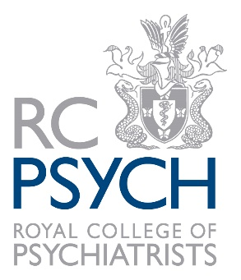
- North West Medical Student of the Year 2025

Please note: Self-nominations, or nominations by students, cannot be accepted. Entries must be accompanied by confirmation of support from the Head of Department or equivalent (see last section).

The deadline for submitting nominations is on 30 September 2025.

Name of nominee | Click or tap here to enter text.
Nominee’s job title | Click or tap here to enter text.
Organisation/Medical School | Click or tap here to enter text.
Address | Click or tap here to enter text.
Email | Click or tap here to enter text.
Entry submitted by:
Name of nominator | Click or tap here to enter text.
Please note, as per the Rules for Entry, nominators must be subscribing College Members, Fellows, Honorary Fellows, Specialist Associates, Affiliates, International Associates or Pre-Membership Psychiatric Trainees.
Job title | Click or tap here to enter text.
Organisation name | Click or tap here to enter text.
Address | Click or tap here to enter text.
Email | Click or tap here to enter text.
The following must be confirmed for your entry to be valid:
Has the nominee given their permission for the entry to go forward? | ☐
Is the nominee aware that they need to submit a completed good standing form on 30 September 2025? The form can be downloaded from the College website. | ☐
Have they agreed to attend/send a representative to the North West Awards ceremony online event on 13 November 2025 if they are shortlisted? | ☐

This award is to recognise a medical student who has demonstrated exceptional performance and dedication during their psychiatry rotations in North West. In particular, recognition to their clinical skills, understanding of mental health disorders, patient empathy and kindness, and showing a commitment to the field of psychiatry thereby raising the profile of the specialty and supporting similarly interested medical students in becoming psychiatrists.

The person nominated should work and/or live in North West.
The entry should demonstrate that the nominee has achieved one or more of the following:
a) Has made a positive impact during their North West medical school placements to the wellbeing of patients and carers.
b) Shows excellent communication skills to patients and carers in North West.
c) Shows commitment to Psychiatry in North West.
d) Shows ability to use excellent psychiatric skills in their clinical studies in North West.
e) Shows a high degree of kindness, compassion and respect to colleagues and patients/ carers.
f) Has raised the positive image of psychiatry across the rest of medicine and society in North West.
g) Demonstrates one, some or all RCPsych Values: Courage, Innovation, Respect, Collaboration, Learning and Excellence.
Entries should relate to work undertaken between January 2024 and December 2024. Activities undertaken outside these dates will not be considered.

Entry summary (maximum 300 words)
Please describe how the nominee meets the Award criteria and why they should be awarded the title North West Medical Student of the Year
This wording may be used for publicity purposes for entries that are shortlisted.
Confirmation of support from the Head of Department or equivalent:
I confirm that the above evidence is accurate to the best of my knowledge.
Name
Signature |  | Job title

Data Protection 
The College’s data protection policy can be found on our website

Thank you for entering the 2025 RCPsych North West Awards.
Please send your completed entry form on 30 September 2025 by email to division.events@rcpsych.ac.uk
Please note that the entry will not be valid until we receive a completed good standing form from the nominee. The good standing form can be downloaded from the College website.

