VIPSIG Newsletter

May 2023

Newsletter Editor: Professor Nandini Chakraborty

Contents

Message from the Chair, Dr Anis Ahmed 2
HURRAH HURRAH: We are 10 years old, Dr Peter Hughes and Dr Sophie Thomson, Ex-Chairs of VIPSIG 7
Volunteering with SMMHEP, Dr Natalie Cook 9
Sudan War: Heart of Africa in Flames, Sudanese Psychiatrist Association in the UK and Ireland 13
Navigating Cultural Difference in Global Mental Health Practice: Lessons from History, Dr Baher Ibrahim 14

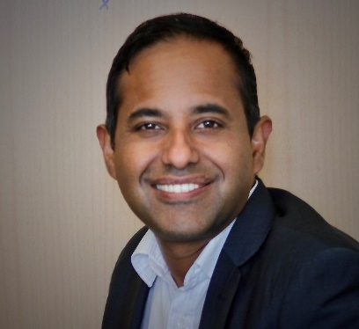
Dr Anis Ahmed MBBS, MRCPsych, PG Cert (Med Edu)
Chair, RCPsych ViPSiG (Volunteering and International Psychiatrists Special Interest Group)

Consultant Forensic Psychiatrist, Birmingham & Solihull Mental Health NHS Foundation Trust
Forensic College Tutor
Honorary Senior Research Fellow, University of Birmingham, England
Clinical Lead in Psychiatry, Aston Medical School, Birmingham. England
@Ani5Ahmed
https://www.rcpsych.ac.uk/members/special-interest-groups/volunteering-and-international/executive-committee

Message from the Chair, Dr Anis Ahmed

It is an immense pleasure to see Professor Nandini Chakraborty taking the initiative to revive the VIPSIG newsletter after a long break following the COVID pandemic. We are aiming to make it a biannual publication and would like to invite you to submit articles. I was delighted to hear the World Health Organisation officially announce the end of the pandemic last week. This is reason enough to celebrate life this summer with hope of continuing volunteering as usual at home and abroad.

I would like you to book some key dates for this year’s planned activities. Our annual VIPSIG conference will take place at the RCPsych premises on Friday 27 October 2023. We are working on the theme and speakers for the conference. If you have any suggestions, please email them to Sigs@rcpsych.ac.uk

VIPSIG now has own twitter account, @RCPsychViPSiG and a hashtag #vipsig, please follow us and retweet our events.

I have had several meetings with UN volunteers in past few months and we held a webinar on 30 March 2023 which was successful in developing sustainable volunteering opportunities for our members, particularly promoting the concept of micro-volunteering. Please find the link to the recording of the webinar:
https://www.rcpsych.ac.uk/members/special-interest-groups/volunteering-and-international/resources/

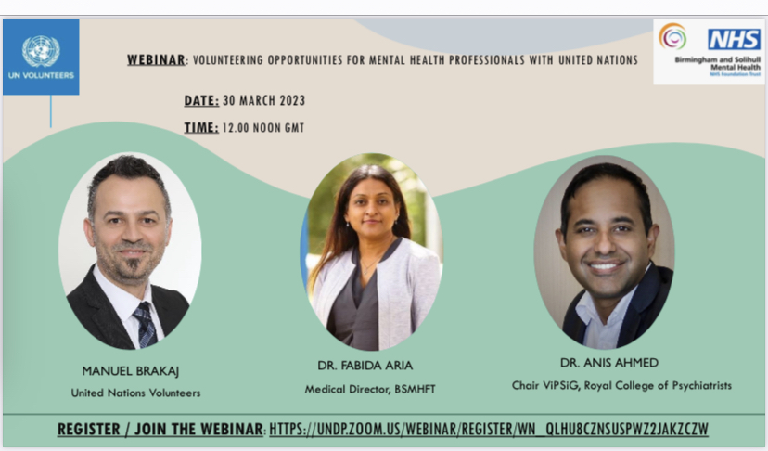

You might be aware that the College is now working on the next phase of International Strategy development. I attended in the last meeting to represent VIPSIG. I have emphasised the need to support our members in facilitating volunteering opportunities and to actively pursue projects that are mutually beneficial for our members as well as host countries and institutions. I am glad to say that my proposal was supported; to widen the remit of international projects in line with the new strategy instead of focusing primarily on priority regions or nations. This will enable our members to explore wider opportunities to volunteer across the globe. I am also trying to ring fence some funding to provide for travel bursaries to our members to support their initiatives in the UK and abroad.
I would urge you to read the brief on the international strategy. Do write to me with your views (vipsig2011@gmail.com). We have our next meeting booked in June to finalise the international strategy. The link for the international strategy document is in the resource page of VIPSIG portal.
https://www.rcpsych.ac.uk/docs/default-source/members/sigs/volunteering-and-international-vipsig/rcpsych-international-strategy-2020---2023.pdf?sfvrsn=1c626100_2

We are eagerly looking for a social media officer and co-editor for our newsletter. Please send your expressions of intertest to Sigs@rcpsych.ac.uk with a brief bio. I am sure you will enjoy your position working with VIPSIG team members. I am keen to expand our executive committee and regional representation to promote volunteering opportunities. I look forward to hearing from you.

As we are publishing this newsletter, sad news of civil war in Sudan has drawn international attention. We have been in communication with our members and partners in assisting victims of the war, please read the message from Sudanese Psychiatrist Association in the UK and Ireland and extend your helping hand to them.

Finally, some events for your diary:

I am delighted to share with you some events and webinars that can help you to find volunteering opportunities and gain CPD certificates.

- A free webinar organised by British Bangladeshi Psychiatrist Association (BBPA) on Perinatal Mental Health service development in low resource setting. Dr Trudi Seneviratne OBE & RCPsych Registrar will deliver a keynote speech on collaborative working and reciprocal learning from volunteering work in perinatal mental health. This webinar will give you opportunities to explore micro volunteering worldwide. Please join us on Sunday 28 May at 1730 British Summer Time/ 2230 Bangladesh time in the link below https://us06web.zoom.us/j/84183243833

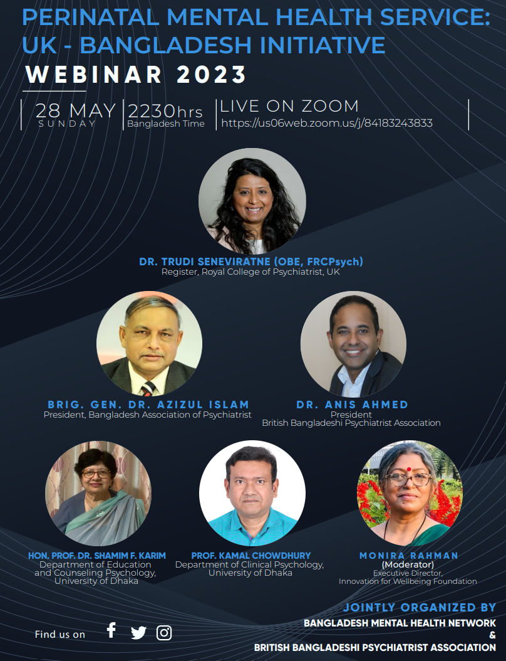

- The British Indian Psychiatrist Association (BIPA) Annual conference will take place in Birmingham on 10 and 11 June. I am honoured to be invited to speak on our work on Judiciary training in raising awareness of mental health issues in legal proceedings. Please register early to get the discounted rate. The details are in the following link https://bipa.org.uk/event/BIPA-Annual-Conference-2023

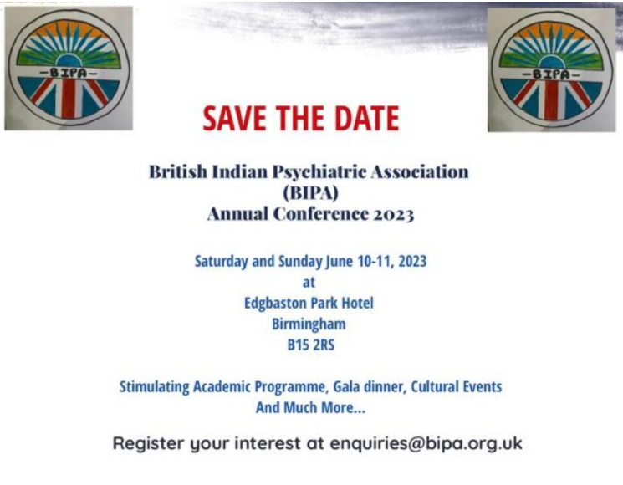

- The British Bangladeshi Psychiatrist Association is hosting an Annual Conference at RCPsych premises on Friday 21 July. This unique conference pooled stakeholders from diverse professional background to address health inequalities and an action plan for volunteering opportunities in UK and abroad with supports from political leaders, business leaders and social entrepreneurs. A number of esteemed speakers are talking at the conference including Rt. Hon. Rushanara Ali, MP, Dr Ananta Dave, RCPsych Diaspora Committee Chair, Dr Lade Smith, President Elect RCPsych, Dr Trudi Seneviratne, Registrar RCPsych, Prof. Quazi Haque, Board Director & Co-founder Elysium Healthcare ,Prof. Piyal Sen, Chair of Special Committee on Human Rights, RCPsych, Prof. Nandini Chakraborty, RCPsych National Lead for Recruitment M G Moula Miah, FRSA, FIH, MCMI; President UKBCCI, Subrina Hossain, Chief Executive of NTV Europe. Poppy Jaman OBE , Former CEO of Mental Health First Aid (MHFA), Baroness Pola Uddin, Life peer at House of Lords and community activist of Bangladeshi heritage. Tickets are selling fast for his conference, please book your place soon in the link below https://www.eventbrite.co.uk/e/bbpa-annual-conference-2023-tickets-640181820057?aff=erelexpmlt
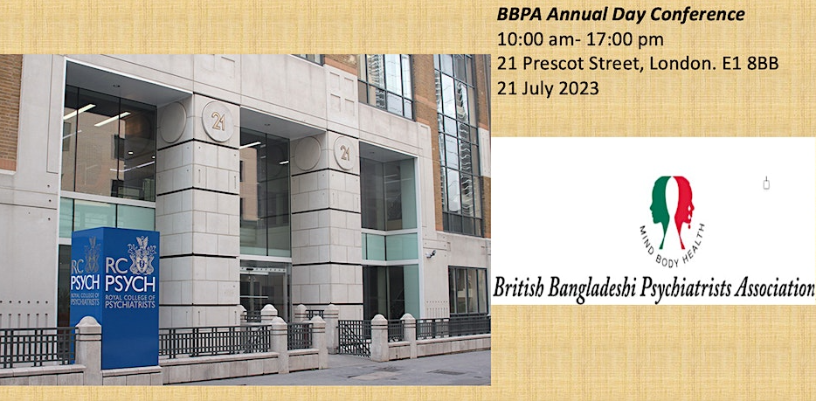

HURRAH HURRAH: We are 10 years old, Dr Peter Hughes and Dr Sophie Thomson, Ex-Chairs of VIPSIG

VIPSIG was born from the enthusiasm of a group of senior psychiatrists at RCPsych in 2011.
It was known that many College members had been doing volunteer work around the world and in the UK. The VIPSIG was created with the aim of supporting these members and others interested in global mental health and UK volunteering. Many College members and fellows are international medical graduates with a heartfelt interest in the mental health of communities around the world.
The VIPSIG aimed to be a place to share knowledge, follow best practice, and build up further opportunities and professionalise volunteering.
VIPSIG has grown substantially into one of the most popular SIGs at the College. It has been providing regular day conferences and training opportunities open to all College members as well as other clinicians interested in volunteering their time and skills. We have had 2 fundraising treks to India and Sri Lanka to support the finances of the volunteering scheme.
The VIPSIG has been the driver of a number of significant global projects in Sudan, Ghana, Indian Kashmir, Myanmar to name but a few.
There is now much work done online as well as more traditional face to face volunteering.
Volunteering work has also shown itself as a tool of recruitment and retention. Many members have used their VIPSIG experience in their interviews for posts and we all see our volunteering work as so important in retention in the NHS. We go away for periods of time but come back reinvigorated and are better doctors for it. The VIPSIG has strongly advocated the recruitment and retention role of volunteering. We advocate for the NHS to enable volunteering and can evidence clear benefits for those on return to their work.
The VIPSIG has been a welcoming place for people at all stages of their professional career from students, trainees, specialist doctors, Consultants and retirees.

Although a College group, there are many associations with non-members, people of different professions which rightly reflects what good professional volunteering is like. We thank particularly our colleague Gergana Manlova who is a psychologist by background but a strong friend of VIPSIG and one of the main drives for editions on psychosis and “depression around the world”.
Newsletters have been very popular and display the breath and diversity of experiences of volunteers.
The edition on psychosis featured stories of psychosis around the world. The last edition of this nature featured depression which from a public health point of view is the most important psychiatric disorder globally. However, psychosis although less common in a society, can be immensely destructive to a person, their family and their community. Psychosis is universal and shares more similar features than differences. The stigma is always there, as are human rights violations and lack of access to relatively easy treatment. Many of us have seen cases of people with psychosis tied up or chained by their families or in hospital for years. We have also seen cases where these people have been liberated in a process that ensured safety and rehabilitation to a dignified life. Our members have been part of helping this happen in many cases. Treating psychosis can get people their lives back, get back with their families and integrate within their communities. We know that right now there are people still chained and tied up. In VIPSIG we champion the ongoing advocacy around all mental health problems. We hope that the edition on psychosis can instil hope. Psychosis can be managed and transform for the better people’s lives.
We would also like to mention that the SIG is about to publish a book on global volunteering, and we invite our members to support this.

Volunteering with SMMHEP, Dr Natalie Cook

Consultant Psychiatrist, Early intervention in psychosis, Tees, Esk and Wear Valleys NHS Foundation Trust

SMMHEP aims to develop sustainable mental health services in Malawi, by supporting medical student and postgraduate psychiatry training since 2006. The base for teaching is Kamuzu College of Health Sciences in Blantyre, whilst the mental health hospital is based 70km away in Zomba. Mental health services in Malawi are underdeveloped, with only 3 psychiatrists for nearly 20 million people.
I was fortunate to join a group of volunteers for a full rotation (7 weeks) to support the delivery of the 4th year curriculum. The teaching programme is varied including lectures, PBL (Problem-Based Learning), case discussions and clinical placement. Outpatient clinics take place at the Queen Elizabeth Hospital in Blantyre. Patients and their families arrive on clinic days and wait to be seen in small, very warm side rooms by nurses, psychiatry trainees and trainees from other specialities on rotation - with the support of a consultant. Groups of students see the patients then present the case to a volunteer, or trainee to form a management plan. There is no way of predicting who will present to the clinic on a given day, which results in a large variety of presentations across the age range. Some of these are less frequently seen in the UK, for example delirium secondary to malaria and cerebral abscess causing psychosis. Assessment is largely reliant on history taking, with limited access to investigations when required. This is challenging in some cases, for example there is no access to cognitive assessments for young people with developmental delay. A more unexpected challenge is the lack of continuity of care – people don’t have a named nurse or professional and the limited notes carried by the patients don’t capture the full history. As clinic attendance is often facilitated by family members, there is a burden associated with transport costs and having to take time off work, which can discourage families from attending. There is no process for tracking follow-up, which means early warning signs or discontinuation of medication are missed until they present as very unwell, sometimes requiring hospital admission.
Zomba Mental Hospital has more inpatients than the intended capacity and there are signs that the infrastructure is deteriorating. There are 4 wards: 2 acute and 2 rehab for male and female. Though I was prepared well by SMHHEP, I was still taken aback by the conditions. The wards have large outdoor courtyards in which most of the patients spend the day. Occupational therapists lead some groups but for many there seems to be a lack of meaningful activity. The hospital isn’t particularly designed to provide privacy with open washing facilities and ward rounds attended by over 20 people with patients wandering in and out. Though I am acutely aware, that I am coming from a different cultural background and the medical students seemed to find this less unusual.
Many of the inpatients had symptoms of psychosis, though there were also people with depression and substance related conditions. Access to medication can be variable in Malawi; supplies of chlorpromazine, haloperidol and fluoxetine seemed consistent whilst I was there. A handful of patients are prescribed clozapine and receive the usual monitoring for this. There is an ECT suite, which will hopefully be functioning again soon. Due to the number of people in hospital, and comparative lack of medical staff, lengths of stay can be long, as there is not the capacity to regularly review each person. Sadly, there are some people who stay at Zomba hospital more long-term. There are stories of people being admitted after crossing borders making it hard to identify their community (though the hospital social worker tries to find this out). Others are taken to Zomba because their families can no longer afford to support their loved ones or stigma around mental illness has led to the person being rejected by their community.
Pathways to care are varied with many people seeking support from traditional healers before attending the clinic or hospital. One 15-year-old was brought in by his mum, he had a diagnosis of bipolar disorder treated with an anti-psychotic and mood stabiliser– the symptoms listed were wandering, talkativeness and aggression. Spending time with the medical students gave the family time to tell their story. It turns out he was trying to ‘wander’ to Mozambique to find work to earn money for his family but was attacked by a group of men, resulting in trauma symptoms. Whereas the aggression was the occasional fight with his sister. His mum became very tearful and shared that she believes the family home, and her son were cursed by her husband’s family, after he died. She has been seeking help from local priests but hasn’t told anyone else as she believes she is to blame. With the help of one of the trainees, we explored some of these cultural beliefs and made plans to reduce the medication.
As the rotation progressed, it was enjoyable to see the students build in confidence. PBL feedback sessions were particularly fun. The students present their learning in a creative way, which results in lots of amusing sketches and songs. They are required to submit long cases including a reflection – this is quite a new concept for the students; many considered the role of culture, impact of stigma and drugs/alcohol. At the end of the rotation, we supported the department with the written exams and OSCEs.
As my time in Blantyre came to an end, it felt positive to see an increasing number of psychiatry trainees aligning with SMMHEP’s mission, but I continued to wonder, how with such limited resources available, the focus could ever move away from hospital-based treatment. I met with a youth social enterprise called iMind (https://imindmw.wixsite.com/) who gave me hope that this may change. Through school-based programmes, radio shows, individualised support, and training mental health advocates, they are working to develop an evidence base, increase mental health awareness, and reduce stigma.
Malawi is a beautiful country with so much to explore; from weekends hiking in the Zomba plateau, tea tasting in plantations and Big 5 safaris. I feel very fortunate to have found time to volunteer between taking up a consultant role.

A further note from SMMHEP
The Scotland Malawi Mental Health Education Project (SMMHEP) has enjoyed close links with individuals and institutions involved in mental health in Malawi since 2006. We are a registered charity managed by a board of trustees and are primarily funded by the Scottish Government. The principal activities are supporting colleagues at Kazumu University of Heath sciences in Malawi in delivering the undergraduate psychiatry curriculum to medical students and supporting the training of postgraduates in psychiatry.
A measure of the success of the project to date is the increase in Malawian psychiatrists – there are now four working full time in the country, three of whom have progressed from medical students through to consultant posts supported at each stage by SMMHEP. There are also currently six post graduate MMed psychiatry trainees who rotate through specialist training posts in South Africa. Although it is hoped that within the next few years there will be enough expertise in Malawi to provide all the psychiatry training there is clearly a long way to go to achieve anything like adequate resourcing in Malawi with a population of nearly 20 million.
Currently SMMHEP recruits volunteers to work on a short-term basis to assist with the medical student teaching including lectures, problem based learning tutorials and clinical teaching. This is organised in four seven-week blocks throughout the year and volunteers usually stay for the whole 7 weeks or for 3 to 4 weeks. We also support longer term volunteers who will also carry out clinical work. All our volunteers are provided with accommodation in Blantyre and a contribution towards expenses.
See our website www.smmhep.org.uk for further information.
Please get in touch with sarahleslie.smmhep@gmail.com if you are interested in volunteering with us.

Sudan War: Heart of Africa in Flames, Sudanese Psychiatrist Association in the UK and Ireland

Many of you may have heard of the heart-breaking and painful conditions in Sudan. An armed conflict between rival factions of the military government of Sudan began on 15 April 2023, when clashes broke out in the capital city of Khartoum/Central Sudan and the Darfur region in Western Sudan. According to the Armed Conflict Location and Event Data Project, more than 750 fatalities have been reported and nearly 4,600 wounded since the conflict began and many more thought to have died due to the disruption of critical services, including health care.

The humanitarian crisis is massive. Khartoum, the capital city, which is the most densely populated city, has been badly damaged and brought to a standstill. The country has weathered many conflicts in the past and the Sudanese people are resilient and resourceful; however, events of recent history have weakened the backbone of the nation leading to a dire state of affairs. The electric power, water, telecommunications, healthcare, and banking system have been hugely impacted. Many people have fled to other states in Sudan or crossed the borders to neighbouring countries to escape the conflict. The journey is fraught with uncertainty and danger.

On Thursday, 11 May 23, a representative group of the Sudanese Psychiatrist Association in the UK and Ireland met with the Royal College of Psychiatrists and the Diaspora Committee under the umbrella of the college to think of joint work to support the people affected by this conflict.

We appreciate all collaborative efforts of support and volunteering.

Sudanese Psychiatrist Association in the UK and Ireland
Sudanesepsychitristuk@gmail.com

Navigating Cultural Difference in Global Mental Health Practice: Lessons from History, Dr Baher Ibrahim

MBChB, MA, MSc, PhD
CT1 Core Psychiatry Trainee, NHSGGC Northeast
Honorary Clinical Lecturer in Psychiatry, College of MVLS, Glasgow University
Affiliate Researcher in History, College of Arts, Glasgow University

Introduction

A core problem in Global Mental Health (GMH) is the navigation of cultural differences in the expression and distribution of mental disorders, and, indeed, of what even constitutes mental illness cross-culturally. This issue has wide reaching implications for how GMH knowledge is practiced and articulated. It is also the focal point of numerous critiques of GMH as ‘neo-colonialist’ and as a form of medical and psychiatric imperialism.

I undertook the London based GMH MSc program in 2015/6. The curriculum involved early exposure to critical readings that argued that Western understandings of mental illness were being imposed by the rich Global North onto the poor Global South. This is the thrust of Ethan Watters’ Crazy Like Us: The Globalization of the American Psyche, which argues that the United States is ‘homogenizing the way the world goes mad’. It is also the argument advanced by China Mills in Decolonizing Global Mental Health: The Psychiatrization of the Majority World, which offers a critical post-colonial reading of the field of GMH. We also read responses of leaders in GMH to these critiques. In this article I argue that GMH practitioners should be at the forefront of critiques of their field, not only because it makes us better practitioners but also because failure to do so allows harmful critiques to flourish, to the detriment of those GMH is intended to serve. I will draw on examples from my own study of GMH and the history of psychiatry.

Histories of Global Mental Health

In GMH textbooks, the start of the field of ‘Global Mental Health’ is often traced to the appearance of the 2007 Lancet series on GMH, or the World Health Organisation’s (WHO) 2001 World Health Report that focused on mental health. Antecedents are identified in the 1978 Alma Ata Declaration on primary care. My own research on the history of humanitarian and refugee mental health suggests that the starting point for a lot of the core concepts of GMH - expanding mental health care into primary care, expanding beyond institutional settings into the community, respect for the human rights of service users, and building political will to tackle mental health problems from a public health viewpoint - can be traced back even further, at least to the end of the Second World War. Before the guns fell silent, European and American psychiatrists and psychoanalysts were grappling with how to respond to the problem of millions of European refugees and the challenges they presented. The experience they gained went on to shape new fields in psychiatry and mental health: notably international mental health and transcultural psychiatry. For example, the Swiss psychiatrist Maria Pfister-Ammende quickly realised that she could never hope to psychoanalyse the tens of thousands of refugees in Switzerland. This line of thinking led her to abandon the couch and free associations in favour of a career as a Mental Health Officer in the newly established WHO, which was at the forefront of the new field of ‘international mental health’. Another psychiatrist, the Scottish HBM Murphy, noted that nothing in his training had prepared him for working with patients from so many different backgrounds as he was seeing in refugee camps in Germany as a Red Cross worker. His work with refugees was central to his later work as a renowned psychiatric epidemiologist and transcultural psychiatrist. Work with the displaced and marginalised, then, has been central to the development of knowledge in psychiatry.

How have practitioners in the arenas of international and global mental health historically engaged with issues of cultural difference? Largely by indulging in stereotypes, which obfuscate at best and dehumanise at worst. In the 1940s, Pfister-Ammende could not understand Russian refugees. Though she acknowledged the language barrier, she also attributed her inability to understand them to their being ‘too inwardly bound to the Soviet system’ and too far removed from a Western individualist way of life. In discussing mental disorders in Eastern European refugees in Britain in 1952, Murphy wondered if ‘patterns of behaviour acceptable in East Europe are being mistaken, initially, for psychotic in Britain’. Decades later, relief workers assisting Ugandan refugees in South Sudan in the 1980s often attributed psychotic symptoms to ‘simply a manifestation of the cultural trappings which all of them carried into the Sudan, along with their school certificates’, while dehumanising them with statements such as ‘Africans do not suffer as “we” do … Africans are used to this. They don’t feel the same way as we do when they lose a child.’ By learning how previous generations attempted to engage with cultural difference, with the benefit of hindsight, we can better appreciate our own position in the sociopolitical structures and institutions we inhabit, and reflect better on how they influence our thinking and practice. Importantly, by learning these precedents, we learn how to navigate critiques of GMH as alleged medical and psychiatric imperialism.

Conclusion

In Decolonizing Global Mental Health, China Mills cites the case of a psychotic homeless woman in Kolkata, India, who was clothed, bathed, and medicated by a mental health outreach NGO. This woman was soon gang-raped and murdered, ostensibly because the NGO’s intervention had made her more visible to the rapists. She was therefore using ‘her dirty skin as camouflage’, expressing agency and resistance in this form. This would be the equivalent of my conducting a Mental Status Examination in the East End of Glasgow and assuming an unwell patient’s dirty, disheveled, malodorous state was part and parcel of their working class culture and ‘normal’ for them. Evidently, criticisms of GMH as neo-colonialist have the potential to be as damaging as the judgments of the 20th century practitioners I have cited above. This is because they both indulge in the same fallacies: the use of dehumanising stereotypes masquerading as ‘cultural sensitivity’; and the elevation of cultural relativism above human suffering. As GMH practitioners active in global racialized hierarchies of inequality, we must constantly reflect on our motives and work to avoid falling in the same trap.

Watters, Ethan. Crazy like us: The globalization of the American psyche. Simon and Schuster, 2010.
Mills, C. "Decolonizing Global Mental Health: The Psychiatrization of the Majority."
Patel, Vikram, and Martin Prince. "Global mental health: a new global health field comes of age." Jama 303, no. 19 (2010): 1976-1977.
Prince, Martin, et. al., "No health without mental health." The lancet 370, no. 9590 (2007): 859-877; World Health Organization. "The World Health Report 2001: Mental health: new understanding, new hope." (2001).
World Health Organization. Declaration of alma-ata. No. WHO/EURO: 1978-3938-43697-61471. World Health Organization. Regional Office for Europe, 1978.
Ibrahim, Baher. "Uprooting, trauma, and confinement: psychiatry in refugee camps, 1945-1993." PhD diss., University of Glasgow, 2021.
Maria Pfister-Ammende. "Mental Hygiene in Refugee Camps.”, in Zwingmann, Charles, Maria Pfister-Ammende (eds.), Uprooting and After... (1973): 241-251.
Murphy, HBM. Comparative psychiatry: The international and intercultural distribution of mental illness (1982).
Maria Pfister-Ammende. "Displaced Soviet Russians in Switzerland.”, in in Zwingmann, Charles, Maria Pfister-Ammende (eds.), Uprooting and After... (1973): 73-102.
United Nations Library Geneva, World Federation for Mental Health, Practical Measures for dealing with the Mental Health Problems of Refugees and Displaced Persons 1952, in UNHCR collection (CDR HEA/MEN/182 D):
Harrell-Bond, Barbara. Imposing Aid. The Ethnography of Displacement and its Aftermath (1986).

